Project Sign Off Document

Fineotech Solutions

The Deliverables

*The following are the deliverables and the files formats*

* Designs – Illustrator Files
* Content – PPT Files and Word Files
* References for Animations in Web Design

References for Animations

**Home Page Banner**

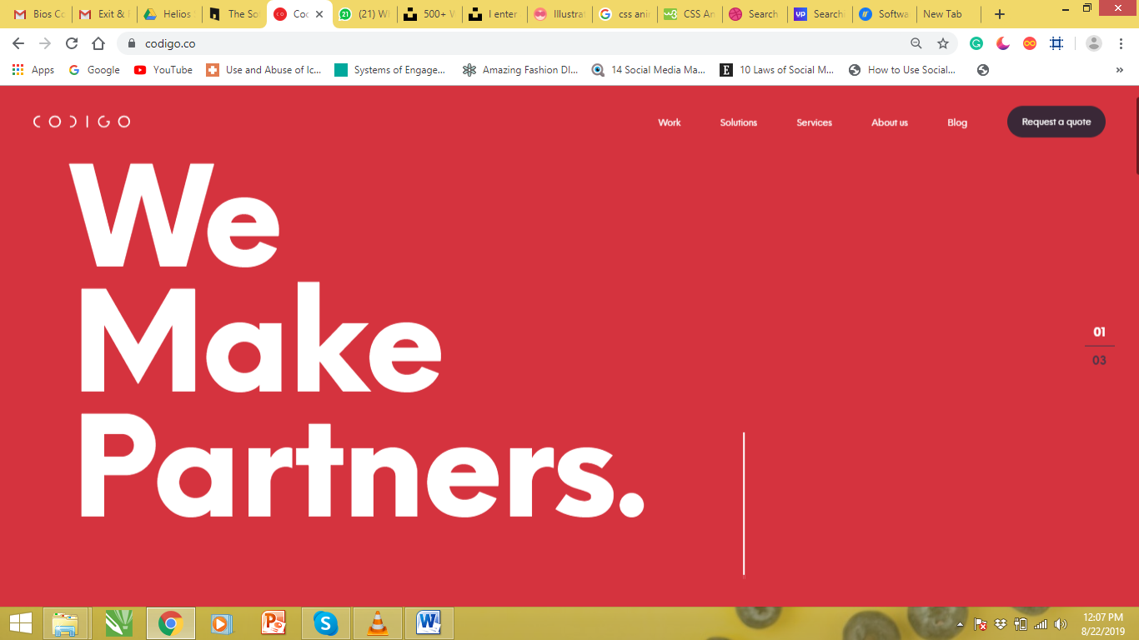

<https://www.codigo.co/> - Text auto-Typing on the Banner

Banner Scrolling in 2-3 seconds.

Banner Scrolling Example - <https://www.intellectsoft.net/>

**For All the Buttons in the Design**

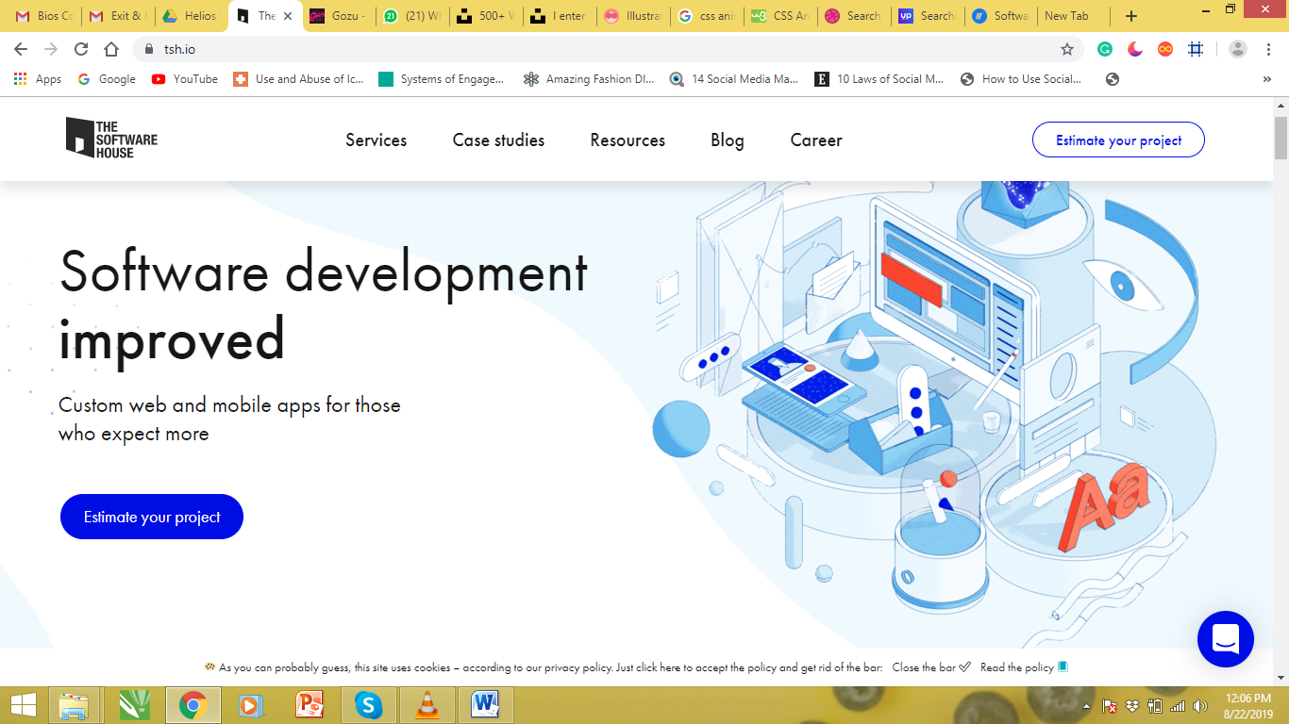

**Hover Effect for the Services Section**

<https://tsh.io/> - See the effect for the button –Estimate your Project.

<https://codepen.io/moitorrijos/pen/gXVMYg> - This CSS effect can be used.

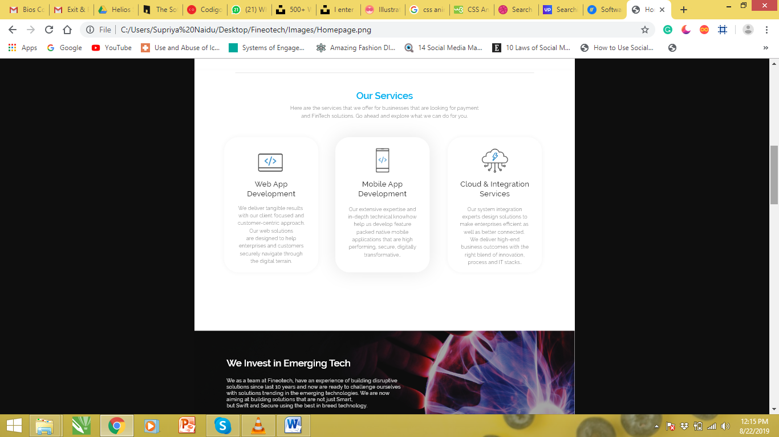

The effect has been shown here in the second block – Mobile App Development.

<https://codepen.io/abhishek747/pen/BbWKVa> - This can be used too.

<https://getbootstrap.com/docs/4.3/utilities/shadows/> - We can use Regular or Large Shadow for this effect.

Blog Section

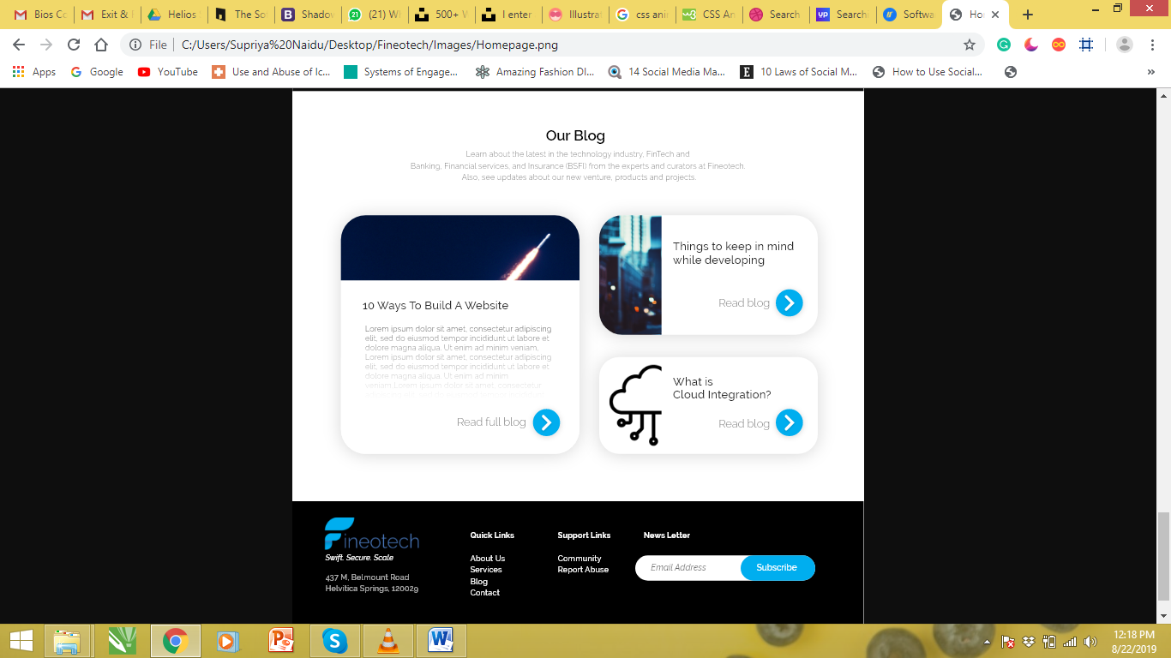

**The Blue Button Effect:** <https://codepen.io/moitorrijos/pen/gXVMYg>